SQL Query – Kaur TARpe24

Algne andmebaasi pilt

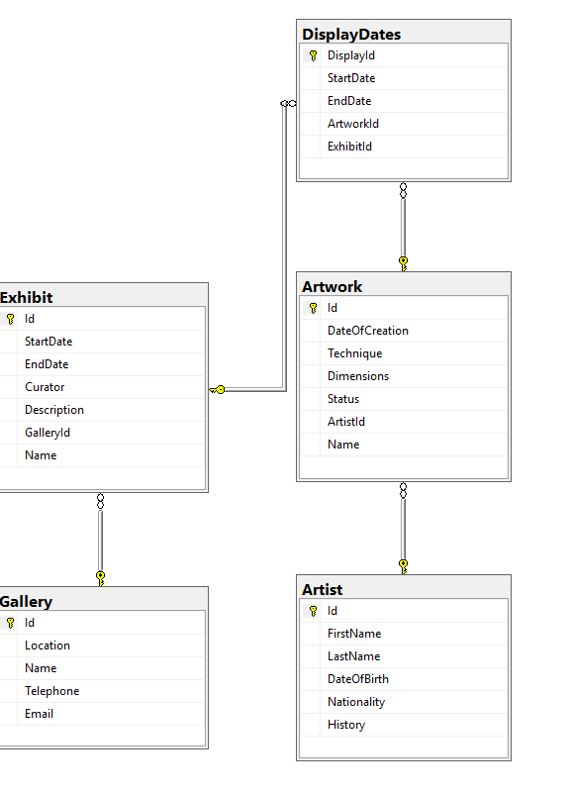

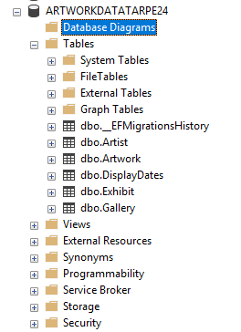

Artist jaoks

SET IDENTITY_INSERT Artist ON -- pidin teema IDENTITY INSERT ON sest muidu program ei lubanud :P

Insert into Artist (Id,FirstName,LastName,DateOfBirth,Nationality,History) values(1,'John','Artist','02-05-1985','American','Came up with the word Art')

Insert into Artist (Id,FirstName,LastName,DateOfBirth,Nationality,History) values(2,'Jane','Artist','03-05-1979','Canadian','Married to John Artist')

Insert into Artist (Id,FirstName,LastName,DateOfBirth,Nationality,History) values(3,'Big','Shot','01-05-1997','Norwegian','Renowned for using Pink and Yellow')

Insert into Artist (Id,FirstName,LastName,DateOfBirth,Nationality,History) values(4,'Leo','Nardo','01-05-1969','Italian','Easily mistaken for much more famous painters')

Insert into Artist (Id,FirstName,LastName,DateOfBirth,Nationality,History) values(5,'Bat','Man','01-05-1978','American','Makes statues out of solid gold')

Select * from Artist

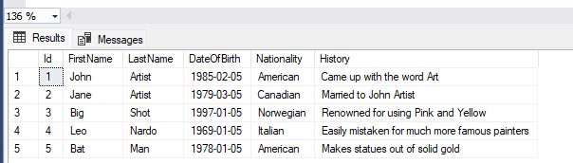

Gallery jaoks

SET IDENTITY_INSERT Gallery ON

Insert into Gallery (Id,Location,Name,Telephone,Email) values(1,'Tallinn','Alpha','161-12632','Alpha.Gallery@gmail.com')

Insert into Gallery (Id,Location,Name,Telephone,Email) values(2,'Tartu','Beta','502-25123','Beta.Gallery@gmail.com')

Insert into Gallery (Id,Location,Name,Telephone,Email) values(3,'Pärnu','Gamma','262-72642','Gamma.Gallery@gmail.com')

Insert into Gallery (Id,Location,Name,Telephone,Email) values(4,'Narva','Delta','433-66232','Delta.Gallery@gmail.com')

Insert into Gallery (Id,Location,Name,Telephone,Email) values(5,'Rakvere','Zeta','171-17632','Zeta.Gallery@gmail.com')

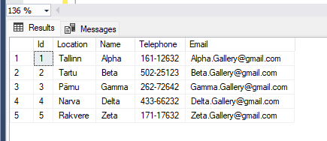

Artwork jaoks

SET IDENTITY_INSERT Artwork ON

Insert into Artwork (Id,[Name],DateOfCreation,Technique,Dimensions,Status,ArtistId) Values (1,'John Time','05-05-1995',3,'350x350',1,1)

Insert into Artwork (Id,[Name],DateOfCreation,Technique,Dimensions,Status,ArtistId) Values (2,'Rectangle','06-08-1994',2,'385x250',2,2)

Insert into Artwork (Id,[Name],DateOfCreation,Technique,Dimensions,Status,ArtistId) Values (3,'Big Lad','02-02-1997',4,'450x850',3,3)

Insert into Artwork (Id,[Name],DateOfCreation,Technique,Dimensions,Status,ArtistId) Values (4,'Small lad','03-04-1991',1,'300x30',4,4)

Insert into Artwork (Id,[Name],DateOfCreation,Technique,Dimensions,Status,ArtistId) Values (5,'Long Lad','02-01-1992',2,'460x3460',5,5)

Select * from Artwork

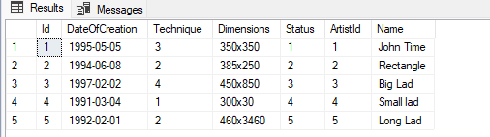

Exhibit Jaoks

SET IDENTITY_INSERT Exhibit ON

Insert into Exhibit (Id,StartDate,EndDate,Curator,Description,GalleryId,Name) values (1,'01-01-2001','02-02-2002','Jane Curator','A Demonstration of Artistry in its truest form',1,'Art-A')

Insert into Exhibit (Id,StartDate,EndDate,Curator,Description,GalleryId,Name) values (2,'02-04-2001','03-06-2003','CURA','Robots like this one!',2,'Art-B')

Insert into Exhibit (Id,StartDate,EndDate,Curator,Description,GalleryId,Name) values (3,'03-06-2001','09-12-2006','Leonardo','A famous artist and his lesser cousins artwork',3,'Bro-B')

Insert into Exhibit (Id,StartDate,EndDate,Curator,Description,GalleryId,Name) values (4,'02-02-2001','06-02-2006','CICA','The life and times of a special someone!',4,'Art-C')

Insert into Exhibit (Id,StartDate,EndDate,Curator,Description,GalleryId,Name) values (5,'01-01-2001','01-08-2012','Bruce Wayne','Strangely the curator seems to like the art here',5,'Gold-G')

Select * from Exhibit

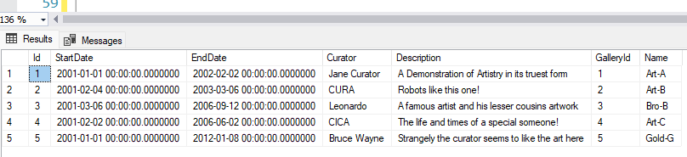

DisplayDates jaoks

SET IDENTITY_INSERT DisplayDates ON

Insert into DisplayDates(DisplayId,StartDate,EndDate,ArtworkId,ExhibitId) values (1,'01-01-2001','02-01-2002',1,1)

Insert into DisplayDates(DisplayId,StartDate,EndDate,ArtworkId,ExhibitId) values (2,'02-03-2000','04-02-2003',2,2)

Insert into DisplayDates(DisplayId,StartDate,EndDate,ArtworkId,ExhibitId) values (3,'03-04-2002','06-03-2001',3,3)

Insert into DisplayDates(DisplayId,StartDate,EndDate,ArtworkId,ExhibitId) values (4,'04-05-2003','07-02-2005',4,4)

Insert into DisplayDates(DisplayId,StartDate,EndDate,ArtworkId,ExhibitId) values (5,'05-07-2004','09-05-2002',5,5)

Select * from DisplayDates

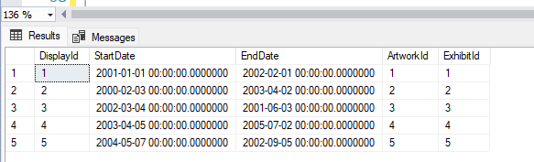

JOIN-id

select Gallery.Name, Exhibit.Name

from Gallery

left join Exhibit

on Exhibit.GalleryId = Gallery.Id

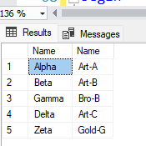

Select Artist.FirstName,Artist.LastName, Artwork.Name

from Artist

left join Artwork

on Artwork.ArtistId = Artist.Id

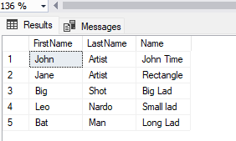

Select Exhibit.Name,Artwork.Name

from Exhibit

left join DisplayDates

on ExhibitId = Exhibit.Id

left join Artwork

on ArtworkId = Artwork.Id

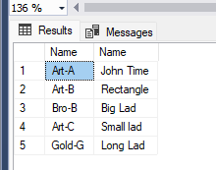

Stored Procedure

Create Procedure dbo.SpSearchGallery

as

begin

Select * from Gallery

end